Chapter 5, Solution 64

G₄

G G₃

G₁
1 G 2
- -
+ 0V + v 0V + +
v_{s} G₂ v_{o}
- ₋

At node 1, v₁=0 so that KCL gives

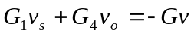 (1)

At node 2,

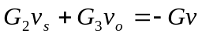 (2)
From (1) and (2),
or
